**MANUAL TO METHODOLOGICAL GUIDE No K151**

**Preamble**

The Public Procurement Office of the University of South Bohemia in České Budějovice (hereinafter referred to as ‘PPO USB’) issues the following manual to the Methodological Guide No 151 on the issue of verification of conflict of interest and application of individual financial sanctions imposed by the EU against Russia and Belarus **when awarding public contracts with an estimated value equal to or less than CZK 500 000.00 excluding VAT.**

Article 1

Basic provisions

The purpose of this manual is to provide all persons authorized to perform acts in public procurement (hereinafter also referred to as ‘purchases’ or ‘market research’) on behalf of the University of South Bohemia in České Budějovice (hereinafter also referred to as ‘USB’ or ‘Procuring Entity’), within the allocated budget funds which such person is authorized to dispose of, and provided that the subject of the purchase is directly related to the scope of activity of the Procuring Entity (hereinafter also referred to as ‘**Purchaser’**).

Article 2

Obligations when purchasing at USB

**This manual to the methodological guide No 151 imposes the following obligations:**

**For public contracts with an estimated value equal to or less than CZK 500 000.00 excluding VAT awarded by direct purchase or market research** in accordance with the Rector's Ordinance No R 389 on the implementation and awarding of public contracts (hereinafter referred to as the ‘Ordinance’) at USB, the Purchaser shall perform the following actions before concluding the contract (purchase order):

1. **The Purchaser shall verify the absence of a conflict of interest of the selected Supplier within the meaning of Section 4b of Act No 159/2006, on Conflicts of Interest (‘*CI*’)**. The Purchaser shall verify this in the register of beneficial owners available at: [https:](https://www3.cribis.cz/login?returnUrl=%2Fsearch)//www3.cribis.cz/ (*or alternatively in the register* [at](https://esm.justice.cz) https://esm.justice.cz, Datlab, or in the case of self-employed persons the Trade Register).

In the case of a foreign legal entity settled in another EU Member State, the Purchaser shall verify the Skyminder module of the Cribis database available at: [https://www3.cribis.cz/](https://www3.cribis.cz/login?returnUrl=%2Fsearch) (login details for the Skyminder module have been provided to the authorised persons of constituent parts and REC units), or alternatively in the register of beneficial owners in the given country. A list of beneficial owner registers of EU Member States is attached as Annexe 1 to this manual.)

If the beneficial owner of the selected Supplier is not registered in the register of beneficial owners or the selected Supplier is a legal entity established outside the EU Member States, the Purchaser shall request a declaration of the beneficial owner including proof of ownership structure directly from the selected Supplier. The Purchaser shall do likewise if any of the beneficial ownership records listed in Annexe 1 are not accessible to the general public. It shall then compare the beneficial owner with public officials pursuant to Section 2(1)(c) of Act No 159/2006, on Conflict of Interest. The current list is available at: <https://cro.justice.cz/>

1. **The Purchaser** **shall verify concerning the selected supplier that it is not a person, entity, or body on the EU sanctions list subject to the** so-called ‘***individual financial sanctions’***[1] imposed by the EU against Russia and Belarus in connection with the Russian-Ukrainian conflict. Verification shall be carried out by the Purchaser, e.g. through the AML Info Check database [https://www3.cribis.cz/](https://www3.cribis.cz/login?returnUrl=%2Fsearch) or through other publicly available sources.
2. **The Purchaser** **shall require all persons involved in the preparation of the procurement conditions, the implementation of the public procurement and persons with influence on the selection of the supplier to make a written statutory declaration stating that there is no conflict of interest.** *It is possible to use the model statutory declaration which constitutes Annexe 2 to this manual or to attach an approved application form if the statutory declaration concerning the absence of conflict of interest is part of it.*

The results of the verification according to (a) and (b) and the statutory declarations according to (c) shall be made by the Purchaser part of the documentation (file) for the purchase, in case of inspection.

Verifications under (a) and (b) can be made directly in VERSO when entering the application form or approving the liquidation certificate by clicking through to the CRIBIS web interface.

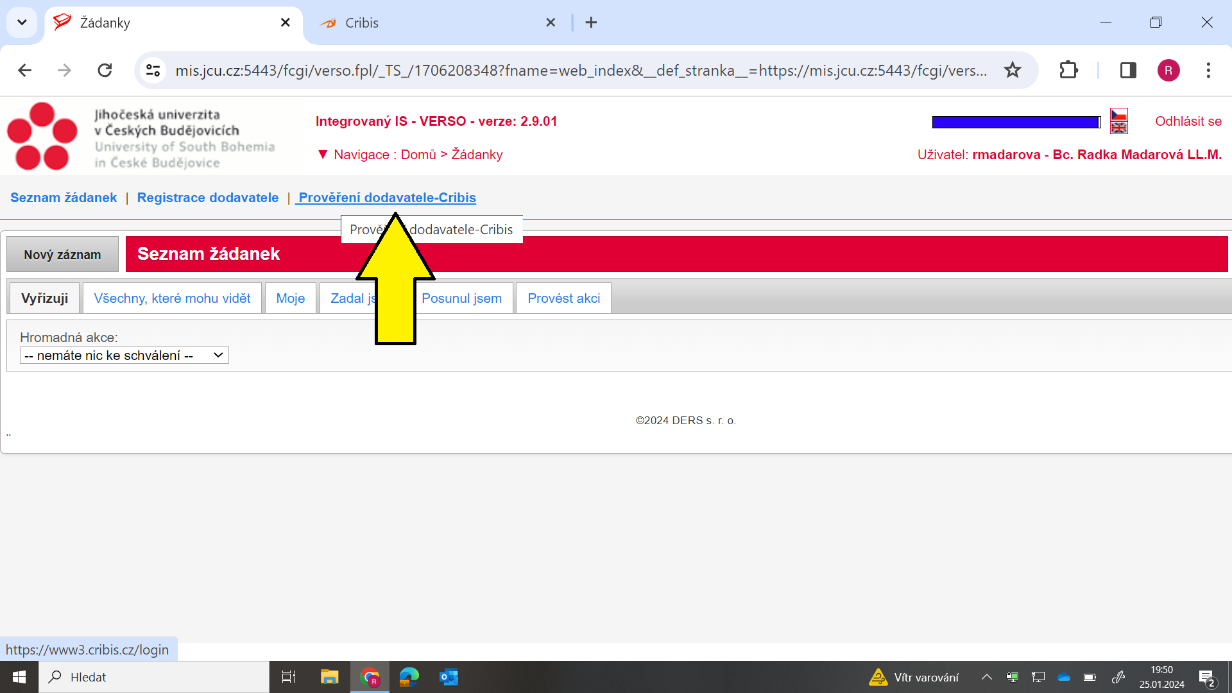

The declaration of no/conflict of interest referred to in c) will be generated in Verso when the application is submitted.

**Article 2**

**Final provisions**

If the Purchaser discovers a conflict of interest concerning the Supplier or persons involved in the preparation of the procurement conditions, the implementation of the public procurement, or persons with influence on the selection of the Supplier, or discovers that the selected Supplier is a person recorded on the EU sanctions list, it must not award the public contract to the selected supplier (enter into a contractual relationship with it) and shall immediately report this fact to his/her superior or to a representative of the Public Procurement Office.

This manual has been prepared in accordance with the current legislation and will be continuously updated. The above recommendations are subject to change depending on newly issued interpretative opinions, requirements of grant providers (which must always be followed regardless of the recommendations in this manual).

Annexes:

*Annexe 1 – Links to the beneficial owner registers in each EU Member State*

*Annexe 2 – Model statutory declaration concerning conflicts of interest*

Prepared by: Bc. Radka Madarová, LL.M., Head of the PPO

Date: 21 March 2024

**Annexe 1 - Links to the beneficial owner registers in each EU Member State**

**Belgium: the** [UBO-Register (Register of Beneficial Owners)](https://finanzen.belgium.be/de/E-services/registre-ubo/)  
**Bulgaria:** [Търговски регистър (Commercial Register)](https://portal.registryagency.bg/)  
**Czech Republic:** [Register of Beneficial Owners](https://esm.justice.cz/ias/issm/rejstrik/)  
**Denmark:** [Centrale Virksomhedsregister (Central Commercial Register)](https://datacvr.virk.dk/data/)  
**Estonia:** [E-äriregister (E-trade Register)](https://ariregister.rik.ee/eng/)  
**Finland:** not accessible to the public   
**Ireland:** [Central Register of Beneficial Ownership](https://rbo.gov.ie/)   
**Italy:** [Registro imprese (Commercial Register)](https://www.registroimprese.it/)  
**Lithuania:** [Uzņēmumu registrurs (Register of Companies)](https://www.registrucentras.lt/p/1108/)   
**Latvia:** [Juridinių asmenų registras (Register of Legal Persons)](https://www.registrucentras.lt/savitarna/)   
**Luxembourg:** [Registre des bénéficiaires effectifs (Register of beneficial owners)](https://www.lbr.lu/mjrcs-rbe/jsp/IndexActionNotSecured.action?time=1630335798139/))   
**Malta:** [X](https://registry.mbr.mt/ROC/index.jsp#involvementSearch.do?involvement=UBO/)   
**Germany:** [Transparenzregister (Transparency Register)](https://www.transparenzregister.de/treg/de/start;jsessionid=890189DAA4CDA04E0B9B5BCC8C3F7037.app11?0/)  
**Netherlands:** [UBO-register (Register of Beneficial Owners)](https://www.kvk.nl/inschrijven-en-wijzigen/ubo-opgave/)   
**Poland:** [Centralny Rejestr Beneficjentów Rzeczywistych (Central Register of Beneficial Owners)](https://crbr.podatki.gov.pl/adcrbr/#/)  
**Portugal:** [Registo Central do Beneficiário Efetivo (Central Register of Beneficiaries)](https://rcbe.justica.gov.pt/Autenticacao)   
**Austria:** [Register der wirtschaftlichen Eigentümer (Register of Beneficial Owners)](https://www.bmf.gv.at/services/wiereg/wiereg-register.html)   
**Romania:** [Registrului Comerțului (Commercial Register)](https://www.onrc.ro/index.php/ro/)  
**Greece:** [Μητρώο Πραγματικών Δικαιούχων (Register of Beneficial Owners)](https://www.gsis.gr/polites-epiheiriseis/epiheiriseis/mitroo-pragmatikon-dikaioyhon/)  
**Slovenia:** [Register of actual owners (Register of beneficial owners)](https://www.ajpes.si/Registri/Drugi_registri/Register_dejanskih_lastnikov/Splosno/)   
**Spain:** [Registro Mercantil Centra (Central Commercial Register)](http://www.rmc.es/Home.aspx/)   
**Sweden:** [Verklig huvudman register (Register of Beneficial Ownership)](https://www.bolagsverket.se/pb/etjanster/verklig-huvudman/)

**Annexe 2 – Model statutory declaration concerning conflicts of interest**

**STATUTORY DECLARATION CONCERNING CONFLICTS OF INTEREST**

**Subject of purchase: ADD NAME**

**I, the undersigned, hereby declare that:**

* my interests do not compromise my impartiality or independence in the context of a public procurement procedure,
* I have no personal interest that compromises my impartiality and independence in connection with the purchase,
* I am not interested in reducing the property or other benefit of the Procuring Entity,
* I do not have a conflict of interest in relation to the entities that submitted the offer and with whom the contract/order is concluded,

I further declare that I did not participate in the preparation of the supplier's offer and that I am not connected to any participant involved in the public procurement by a personal, employment or other similar relationship.

|  |
| --- |
| Name, position, signature: |

In České Budějovice, on

1. <https://fau.gov.cz/sankce-proti-rusku>